AI ASSISTED CODING
FINAL TEST
SET-9
Prompt Engineering (Scenario)
You must create and refine a prompt that instructs AI to generate a Python function to
compute compound interest for a finance bot.
(Include documentation + test cases.)
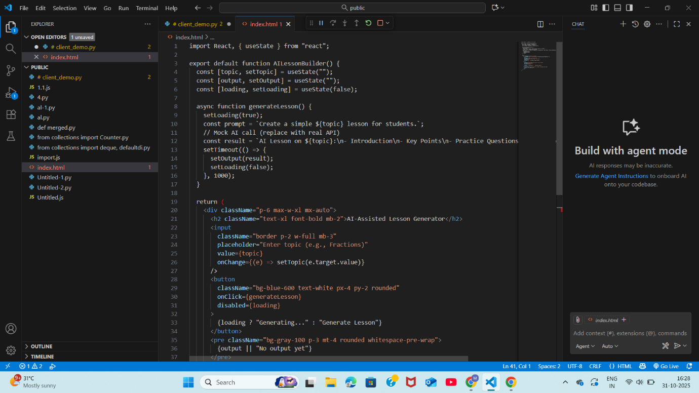

OUTPUT:
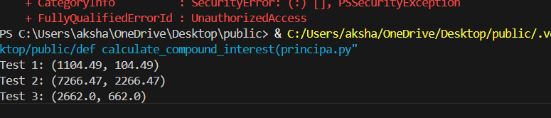

2. SQL Generation (Scenario)
A training academy needs tables for:
• Trainees
• Subjects
• Enrollments
Use AI to generate:
• schema
• sample inserts
• SQL queries to enroll trainees and view enrollments
(Add comments + tests.)
CREATE TABLE Trainees(
2 TraineeID NUMBER GENERATED ALWAYS AS IDENTITY PRIMARY KEY,
3 FullName VARCHAR2(100) NOT NULL,
4 Email VARCHAR2(120) UNIQUE,
5 Phone VARCHAR2(15)
6 );

Table created.

SQL> CREATE TABLE Subjects (
2 SubjectID NUMBER GENERATED ALWAYS AS IDENTITY PRIMARY KEY,
3 SubjectName VARCHAR2(100) NOT NULL,
4 DurationWeeks NUMBER NOT NULL
5 );

Table created.

SQL> CREATE TABLE Enrollments (
2 EnrollmentID NUMBER GENERATED ALWAYS AS IDENTITY PRIMARY KEY,
3 TraineeID NUMBER NOT NULL,
4 SubjectID NUMBER NOT NULL,
5 EnrollDate DATE DEFAULT SYSDATE,
6
SQL> -- Foreign Keys
SQL> FOREIGN KEY (TraineeID) REFERENCES Trainees(TraineeID),
SP2-0734: unknown command beginning "FOREIGN KE..." - rest of line ignored.
SQL> FOREIGN KEY (SubjectID) REFERENCES Subjects(SubjectID)
SP2-0734: unknown command beginning "FOREIGN KE..." - rest of line ignored.
SQL> );
SP2-0042: unknown command ")" - rest of line ignored.
SQL> CREATE TABLE Enrollments (
2 EnrollmentID INT PRIMARY KEY AUTO_INCREMENT,
3 TraineeID INT NOT NULL,
4 SubjectID INT NOT NULL,
5 EnrollDate DATE DEFAULT (CURRENT_DATE),
6 FOREIGN KEY (TraineeID) REFERENCES Trainees(TraineeID),
7 FOREIGN KEY (SubjectID) REFERENCES Subjects(SubjectID)
8 );
EnrollmentID INT PRIMARY KEY AUTO_INCREMENT,
*
ERROR at line 2:
ORA-00907: missing right parenthesis

SQL> CREATE TABLE Enrollments (
2 EnrollmentID NUMBER GENERATED ALWAYS AS IDENTITY,
3 TraineeID NUMBER NOT NULL,
4 SubjectID NUMBER NOT NULL,
5 EnrollDate DATE DEFAULT SYSDATE,
6
SQL> CONSTRAINT pk_enrollments PRIMARY KEY (EnrollmentID),
SP2-0734: unknown command beginning "CONSTRAINT..." - rest of line ignored.
SQL> CONSTRAINT fk_enroll_trainee FOREIGN KEY (TraineeID)
SP2-0734: unknown command beginning "CONSTRAINT..." - rest of line ignored.
SQL> REFERENCES Trainees (TraineeID),
SP2-0734: unknown command beginning "REFERENCES..." - rest of line ignored.
SQL> CONSTRAINT fk_enroll_subject FOREIGN KEY (SubjectID)
SP2-0734: unknown command beginning "CONSTRAINT..." - rest of line ignored.
SP2-0044: For a list of known commands enter HELP
and to leave enter EXIT.
SQL> REFERENCES Subjects (SubjectID)
SP2-0734: unknown command beginning "REFERENCES..." - rest of line ignored.
SQL> );
SP2-0042: unknown command ")" - rest of line ignored.
SQL> CREATE TABLE Enrollments (
2 EnrollmentID NUMBER GENERATED ALWAYS AS IDENTITY,
3 TraineeID NUMBER NOT NULL,
4 SubjectID NUMBER NOT NULL,
5 EnrollDate DATE DEFAULT SYSDATE,
6 CONSTRAINT pk_enrollments PRIMARY KEY (EnrollmentID), CONSTRAINT fk_enroll_trainee FOREIGN KEY (TraineeID)
7 REFERENCES Trainees (TraineeID),
8 CONSTRAINT fk_enroll_subject FOREIGN KEY (SubjectID)
9 REFERENCES Subjects (SubjectID)
10 );

Table created.

SQL> CREATE TABLE Enrollments (
2 EnrollmentID NUMBER GENERATED ALWAYS AS IDENTITY,
3 TraineeID NUMBER NOT NULL,
4 SubjectID NUMBER NOT NULL,
5 EnrollDate DATE DEFAULT SYSDATE,
6 CONSTRAINT pk_enrollments PRIMARY KEY (EnrollmentID), CONSTRAINT fk_enroll_trainee FOREIGN KEY (TraineeID)
7 REFERENCES Trainees (TraineeID),
8 CONSTRAINT fk_enroll_subject FOREIGN KEY (SubjectID)
9 REFERENCES Subjects (SubjectID)
10
SQL> CREATE TABLE Enrollments (
2 EnrollmentID NUMBER GENERATED ALWAYS AS IDENTITY,
3 TraineeID NUMBER NOT NULL,
4 SubjectID NUMBER NOT NULL,
5 EnrollDate DATE DEFAULT SYSDATE,
6 CONSTRAINT pk_enrollments PRIMARY KEY (EnrollmentID), CONSTRAINT fk_enroll_trainee FOREIGN KEY (TraineeID)
7 REFERENCES Trainees (TraineeID),
8 CONSTRAINT fk_enroll_subject FOREIGN KEY (SubjectID)
9 REFERENCES Subjects (SubjectID)
10 );
CREATE TABLE Enrollments (
*
ERROR at line 1:
ORA-00955: name is already used by an existing object

SQL> INSERT INTO Trainees (FullName, Email, Phone) VALUES;
INSERT INTO Trainees (FullName, Email, Phone) VALUES
*
ERROR at line 1:
ORA-00936: missing expression

SQL> INSERT INTO Trainees (FullName, Email, Phone) VALUES
2 ('Aarav Sharma', 'aarav@example.com', '9876543210');

1 row created.

SQL> INSERT INTO Trainees (FullName, Email, Phone) VALUES
2 ('Diya Patel', 'diya@example.com', '9876500001');

1 row created.

SQL> INSERT INTO Trainees (FullName, Email, Phone) VALUES
2 ('Rohan Singh', 'rohan@example.com', '9876500012');

1 row created.

SQL> INSERT INTO Subjects (SubjectName, DurationWeeks) VALUES ('Python Programming', 6);

1 row created.

SQL> INSERT INTO Subjects (SubjectName, DurationWeeks) VALUES ('Data Science', 8);

1 row created.

SQL> INSERT INTO Subjects (SubjectName, DurationWeeks) VALUES ('Web Development', 10);

1 row created.

SQL> INSERT INTO Enrollments (TraineeID, SubjectID)
2 VALUES (1, 2);

1 row created.

SQL> SELECT
2 E.EnrollmentID,
3 T.FullName AS Trainee,
4 S.SubjectName AS Subject,
5 E.EnrollDate
6 FROM Enrollments E
7 JOIN Trainees T ON E.TraineeID = T.TraineeID
8 JOIN Subjects S ON E.SubjectID = S.SubjectID
9 ORDER BY E.EnrollmentID;

ENROLLMENTID
------------
TRAINEE
--------------------------------------------------------------------------------
SUBJECT
--------------------------------------------------------------------------------
ENROLLDAT
---------
1
Aarav Sharma
Data Science
21-NOV-25

SQL> INSERT INTO Trainees (FullName, Email, Phone)
2 VALUES ('Meera Nair', 'meera@example.com', '9000000001');

1 row created.

SQL>
SQL> INSERT INTO Enrollments (TraineeID, SubjectID)
2 VALUES (4, 1);

1 row created.

SQL> SELECT COUNT(*) AS TotalEnrollments FROM Enrollments;

TOTALENROLLMENTS
----------------
2

SQL> SELECT
2 T.TraineeID, T.FullName
3 FROM Trainees T
4 LEFT JOIN Enrollments E ON T.TraineeID = E.TraineeID
5 WHERE E.EnrollmentID IS NULL;

TRAINEEID
----------
FULLNAME
--------------------------------------------------------------------------------
2
Diya Patel

3
Rohan Singh

SQL> SELECT
2 S.SubjectName,
3 COUNT(E.TraineeID) AS EnrolledStudents
4 FROM Subjects S
5 LEFT JOIN Enrollments E ON S.SubjectID = E.SubjectID
6 GROUP BY S.SubjectName;

SUBJECTNAME
--------------------------------------------------------------------------------
ENROLLEDSTUDENTS
----------------
Data Science
1

Python Programming
1

Web Development
0

